Industrial Injury and Weather Factors Datamining

GyuHyeok Choi¹, HyunJin Yeo²

Department of Visual Contents, Graduate School of DongSeo University¹
Division of Digital Contents, DongSeo University²
47 JuRye-Ro, SaSang-Gu,
Busan, South Korea
Choi8603@hamail.net¹
hjyeo@dongseo.ac.kr²

Abstract

The Korea Meteorological Administration has been released diverse weather information related index such as ultraviolet, food poisoning, sensory temperature, and laundry washing those are statistically analyzed and indexed. In above sense, the Korea Occupational Safety and Health Agency has developed and supplied industrial work weather index with practical experiences via mobile application. However, the industrial work weather index is not popular to workers because of accuracy issues. This research suggests datamining base industrial weather index with datamining weather factors data and industrial injury data.

Keywords-Industrial Injury, Industrial Weather, Weather and Industrial Injury, Datamining

I. Introduction

An industrial injury prediction has been studied and applied in various industry area especially construction where high altitude work usually performed. Through various studies and application cases, industrial injury has been dramatically reduced since late 20century to now. However, almost all efforts are related to work condition such as caution mark and equipments for high altitude work, when external condition studies are not sufficient.
Meanwhile a weather codition also has been studied for mankind diverse activity such as physical exercise, laundry washing, ultraviolet warning and others. Those weather condition related indexes shows many weather related indexes such as temperature, humidity, wind speed and others are highly connected and effects to human conditions which could lead labor conditions. Fig1 shows
In this research, we dataminied weather four related factors and industrial accident injury data to find out relation and make warning index for industrial injury.

II. Data Handling

A.Weather Data Cleansing

This study uses five years weather data from the KMA(Korea Meterological Administration) an hour diced. Since the weather measurement spot is not directry accurate to regional section of Korea, transfer measurement instrument spot to regional data is firstly performed. In this study we transfer spot number to minimum legal region size ‘Dong’ and mark post code for them.
There are also multiple spots in same region because of height of instrument and other factors. Since purpose of this study is find out relation between weather factors and industrial injury, we choose the closer spot to downtown or lower height. Final dataset consist of 197,382 records

B. Industrial Injury Data Cleansing

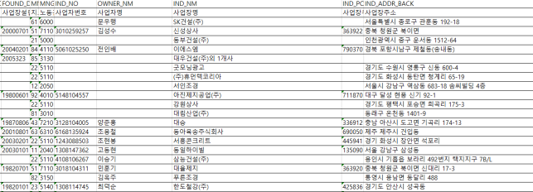
The most hard work for cleansing industrial injury data from KOSHA(Korea Occupational Safety and Health Agency) is informal address because input interface is not formal and there was system change of addressing in 2014.
Fig. 1 Industrial Injury Informal Dataset

Despite of keyword algorithm to match minimum regional name ‘Dong’ to weather data, there were 391 data could not work with the algorithm that lead manual work for matching. Postal code is also marked after formulate address.
We have two dataset consist of serious injury such as death set, and general injury set those merge into one dataset

C. Analysis Dataset

Through merging two datacleaed dataset: weather and industrial injury, the dataset for analysis is set including past three years 518,208 injury records. Fig2 shows merged dataset which we utilize for this research. The dataset has type of accident such as fall, miss-step, cut and other injury type, accident time, region, and weather factors at injury time(date): temperature, wind speed, humidity, rain and snow quantity.
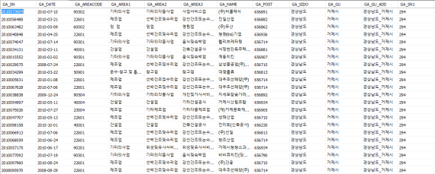
Fig2. Final Dataset to Analysis

III. Result

Table I Shows Pearson-correlation result between temperature and injury frequency to make construction weather index. Since the lack of pages, decision tree classification result via type of injury and seasons are skipped.

TABLE I
PEARSON-CORRELATION RESULT
 |  | Temp | Humid | W.S | Rain | Snow
Accident  Freq. | Pearson Cor | .017 | -.045 | .092 | .005 | .010
Accident  Freq. | P-value | .000 | .000 | .000 | .004 | .000
Accident  Freq. | N | 329086 | 329086 | 329086 | 329086 | 329086

As one can see Table I, there are reliable correlations between accident frequency and weather factors. For indexing temperature divided to five sectors.

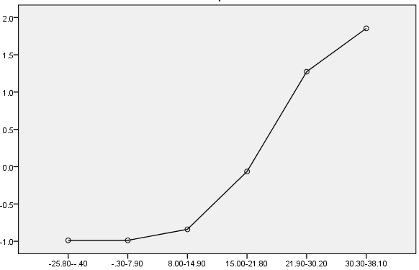
Fig3. Pearson Correlation between Temperature and Injury Frequency

Fig3 shows indexing result of temperature. To indexing temperature factor is divided to many sectors from -25 degree to 38.1 degree. Each weather factors are divided and analyzed with type of injury.
TABLE II shows sample final result of this research which indicate weather condition seven grade by injury type. A stucking injury is related to two weather factors: Temperature and windspeed. The grades standard is normal (grade4) and lower grade is better for work when higher is worse.
There are other indexes via injury type and weather factors affecting those injuries.

TABLE II
STUCK INJURY INDEX
Grade and  InjuryType |  | G1 | G2 | G3 | G4 | G5 | G6 | G7
S  T  U  C  K | Temp
S  T  U  C  K | TEMP | -24.1 ~ -2.2 | -2.1 ~ 5.5 | 5.6~  11.8 | 11.9~  17.7 | 17.8~  24.0 | 24.1~  31.7 | 31.8~  37.5
S  T  U  C  K | TEMP(Freq) | 5,079 | 13,008 | 12,961 | 11,671 | 17,447 | 17,791 | 1,055
S  T  U  C  K | Injury Rate | 2.60% | 2.50% | 2.73% | 2.60% | 2.63% | 2.93% | 3.05%
S  T  U  C  K | Wind Speed
S  T  U  C  K | WS | 0-1.1 | 1.2 ~ 2.1 | 2.2 ~ 3.0 | 3.1 ~ 4.0 | 4.1 ~ 5.2 | 5.3 ~ 23.6 | -
S  T  U  C  K | WS(Freq) | 15,299 | 20,306 | 16,761 | 13,239 | 8,159 | 5,248 | -
S  T  U  C  K | Injury Rate | 2.16% | 2.71% | 3.05% | 3.09% | 2.93% | 2.27% | -

IV. Conclusion

The results of this research shows major weather indexes to prevent industrial injury. The index is dividedby injury type because injury type is different via industry type. For example, falling is highly related to building construction.
Since this research has one purpose: developing indexes for industrial injury, there are limitations for further research.
First, analysis for prediction is insufficient. Second, dividing sector for grade has some forced analysis work.
Though analaysis in this research is basical level in spite of large quantity of data cleasing work, it could be fundamental research for further research model such as prediction model and sensor related business model.

References

[1] B.C. Catherine, and A.R, Daniel, “Assessing the effects of Weather Conditions on Physical Activity Partivipation Using Objectives Measures", International Journal of Environment Research and Public Health, Vol.6, pp.2639-2654, 2009.
[2] N.A. Kartam, I. Flood, and P. Koushki, “Construction safety in Kuwait: issues, procedures, problems, and recommendations", Safety Science, Vol.36, pp.163-184, 2000.
[3] Y.S. Kim, “Industrial Injury Prediction via Weather Cast”, OSH Research Brief, 2014.
[4] H.J. Yoon, J.H. Kim, and P. Kim, “Research for Early Warning System Information Strategy”, Korea Occupational Safety and Heath Agency, 2009.

